Add a New Source under: References>Citations & Bibliography>Insert Citation>Add New Source

Use the information below to complete the Sources.

(Austen, 2016)

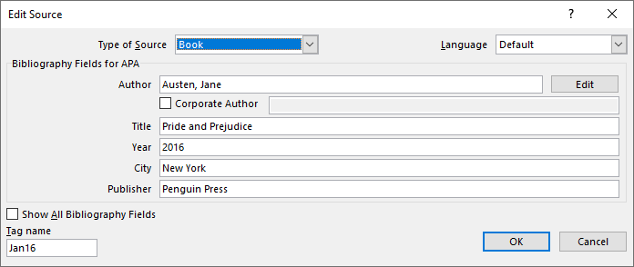

(LaSalle, 2017)

